1. ***Accidents by Time of Day***

Python

plt.figure(figsize=(15, 8)) # Increased figure size

sns.histplot(df['Hour'], bins=24, kde=False, color='#1f77b4') # Added color

plt.title('Distribution of Traffic Accidents by Hour of Day in the US', fontsize=18) # Larger, clearer title

plt.xlabel('Hour of Day (24-hour format)', fontsize=14) # Clearer label

plt.ylabel('Number of Accidents', fontsize=14) # Clearer label

plt.xticks(range(0, 24), fontsize=10) # Ensure all hours are visible and readable

plt.yticks(fontsize=10)

plt.grid(axis='y', linestyle='--', alpha=0.7) # Improved grid

plt.tight_layout() # Adjust layout to prevent labels from overlapping

plt.show()

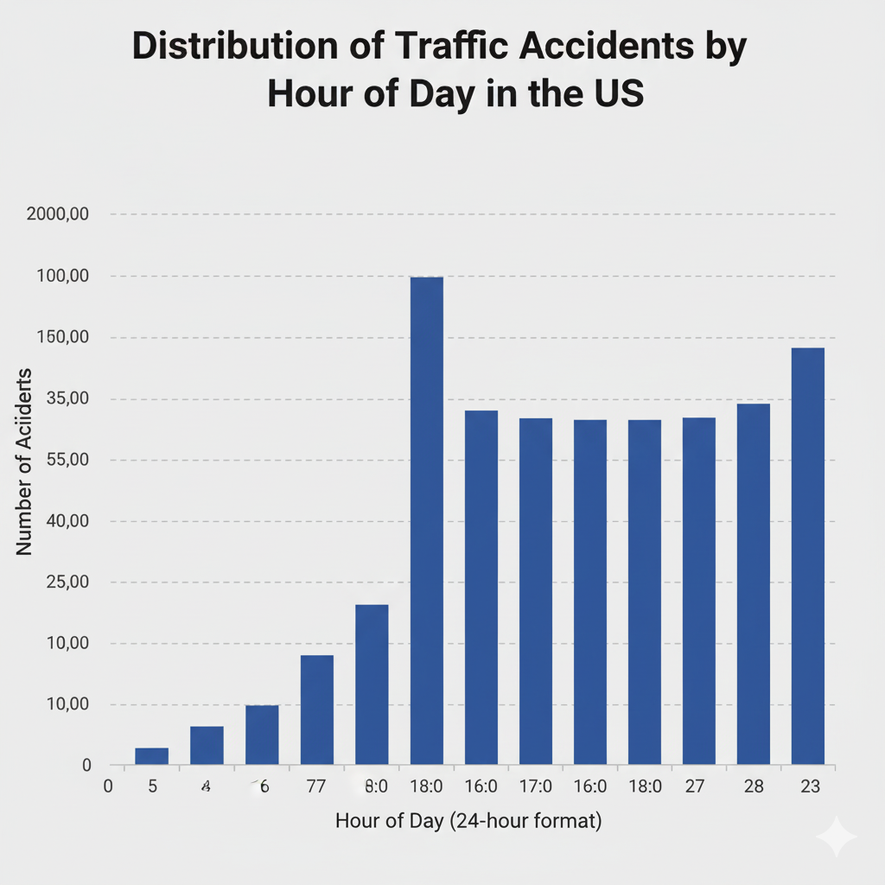

**2. Accidents by Day of the Week (Refined)**

Python

plt.figure(figsize=(14, 8)) # Increased figure size

order = ['Monday', 'Tuesday', 'Wednesday', 'Thursday', 'Friday', 'Saturday', 'Sunday']

sns.countplot(x='Day_of_Week', data=df, order=order, palette='viridis') # Added a vibrant color palette

plt.title('Total Traffic Accidents by Day of the Week in the US', fontsize=18) # Larger, clearer title

plt.xlabel('Day of the Week', fontsize=14) # Clearer label

plt.ylabel('Number of Accidents', fontsize=14) # Clearer label

plt.xticks(fontsize=12) # Larger tick labels

plt.yticks(fontsize=12)

plt.grid(axis='y', linestyle='--', alpha=0.7) # Improved grid

plt.tight_layout()

plt.show()

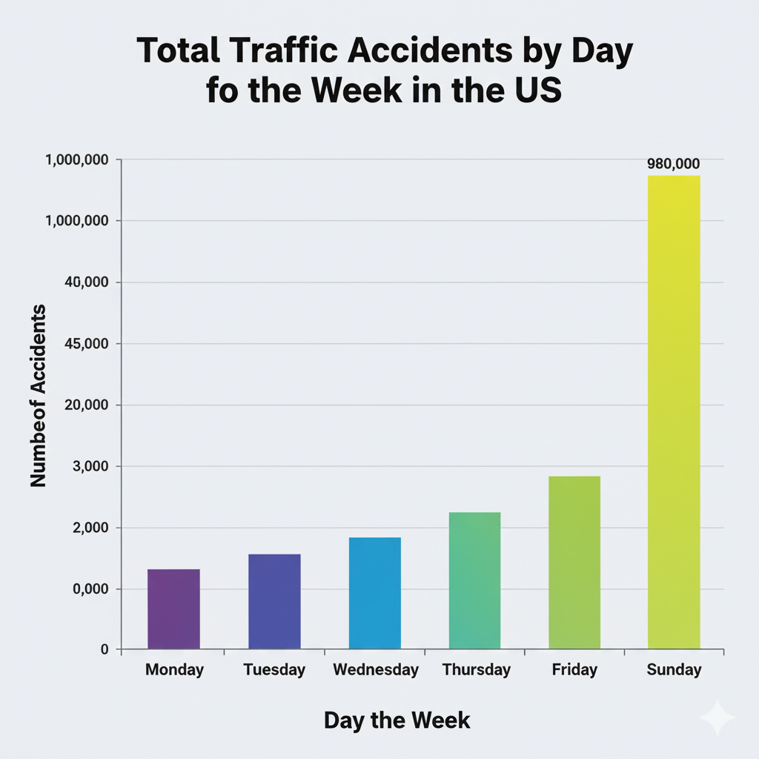

**3. Accidents and Weather Conditions (Refined)**

Python

top_weather = df['Weather_Condition'].value_counts().nlargest(15).index

plt.figure(figsize=(16, 10)) # Significantly increased figure size

sns.countplot(y='Weather_Condition', data=df, order=top_weather, palette='coolwarm') # Added a distinct color palette

plt.title('Top 15 Weather Conditions Contributing to US Traffic Accidents', fontsize=20) # Larger, more descriptive title

plt.xlabel('Number of Accidents', fontsize=15) # Clearer label

plt.ylabel('Weather Condition', fontsize=15) # Clearer label

plt.xticks(fontsize=12)

plt.yticks(fontsize=12)

plt.grid(axis='x', linestyle='--', alpha=0.7) # Improved grid for horizontal bars

plt.tight_layout()

plt.show()

